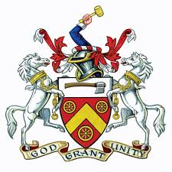
THE WORSHIPFUL COMPANY OF WHEELWRIGHTS

Livery Committee

Contact
Harry Fell
Tel: 07518917006
Email: Harry.fell@vellcotyre.co.uk

1st May 2021
Informal Event – Go Karting at London Docklands 3rd July 2021 at 2.05pm

Dear Liveryman and Freeman,

I am very pleased to announce that with the support of the Master we are holding a Go karting event at the London Docklands.

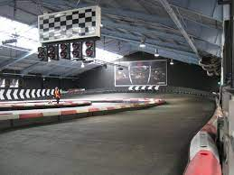
The event will commence at 2.05pm at Team Sport London Docklands with a safety briefing and safety equipment allocation. Ready for 2.35pm Grand Prix style racing which will be qualifying followed by a race then finished with a trophy presentation for the top three drivers. The event is particularly (but not exclusively) aimed at younger/new and potential members to encourage involvement in the Livery.

Numbers are limited to 36 and therefore places are strictly on a first come first served basis.

Yours Sincerely

Harry Fell

I/We would like to attend the Wheelwright’s informal event on the 3rd July 2021

Name …………………………………………. e-mail………………………………………………………………………..

Address……………………………………………………………. Telephone No…………………………………………..

I would like to bring a guest/s ………………………………………………………………… (name of guest/s)

I enclose a cheque or bank t/f for £ ……….. to cover the cost of ……… ticket(s) at £45 per head
(Cheques payable to H Fell or by bank transfer to Reference is your surname followed by Wheelwrights 3/7) Sort: 40-13-47 Acc: 30091278

Harry Fell, 7 Bridlington street, Hunmanby, North Yorkshire, YO14 0JR.

